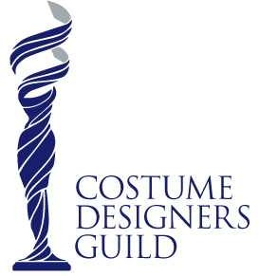
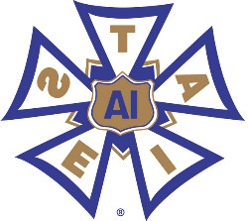
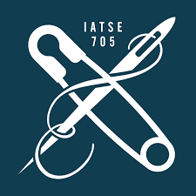
Emily Heyman
C: 310.745.1583 emilyheymancostumes@gmail.com
emilyheyman.com

FEATURE
Title Position Director Cast/Notes
The Peanut Butter Falcon Asst. Costume Designer Mike Schwartz Shia LaBeouf, Dakota Johnson, John Hawkes Equals Asst. Costume Designer Drake Doremus Kristen Stewart, Nicholas Holt, Jacki Weaver The Town That Dreaded Sundown Asst. Costume Designer Alfonso Gomez-Rejon Addison Timlin, Dennis O’Hare, Gary Cole Showing Roots Key Costumer Michael Wilson Maggie Grace, Uzo Aduba, Elizabeth McGovern Keanu Set Costumer Peter Atencio Jordan Peele, Keegan Michael Key, Method Man

EPISODIC
Mother Mary Costume Designer Dan Gregor Betsy Sodaro, Rachael Bloom (Pilot – CBS)
Lady Time Costume Designer Rachel Goldenberg Betsy Sodaro, Kirby Howell-Baptiste (not released)
Winks Asst. Costume Designer Adam Donald Molly Austin, Shamikah Martinez (not released)
Crossbones Asst. Costume Designer Neil Cross (Creator) John Malkovich, Claire Foy, Richard Coyle
Pen15 S1& S2 Costume Supervisor Sam Zvibleman Maya Erskine, Anna Konkle, Taylor Nichols
Joe Pera Talks With You S2 Costume Supervisor Marty Schousboe Joe Pera, Jo Firestone, Connor O’Malley
Tacoma FD S1 Costume Supervisor Kevin Heffernan Kevin Heffernan, Steve Lemme
The Exorcist S1 Key Costumer Jeremy Slater (Creator) Alfonso Herrera, Ben Daniels, Gina Davis

COMMERCIAL

Twenty Twenty Costume Designer Micho Rutare Win America Back – PAC, American Meme
Bud Light | Costume Designer | Rachel Goldenberg | “Ritas Spritz”
3M | Costume Designer | Rachel Goldenberg | “It’s Time”
GoDaddy | Costume Designer | Jonpaul Douglas | “Armless Bowling”
Aldi | Costume Designer | Pasqual Gutierrez | “We Know Moms”
Lenovo Yoga Tablet II | Costume Designer | Anthony Pham | “Grandma’s Day”

SHORT FILM (Jameson First Shot - Film Writer’s Competition produced by Dana Brunetti)

Beauty Mark | Costume Designer | Cameron Thrower | Maggie Gyllenhaal, Conor O’Farrell
Home | Costume Designer | Kat Wood | Maggie Gyllenhaal, Glenn Plummer
The New Empress | Costume Designer | Jason Perini | Maggie Gyllenhaal, Roberta Bassin
Jump! | Costume Designer | Jessica Valentine | Uma Thurman, Barak Hardley
The Gift | Costume Designer | Ivan Petukhov | Uma Thurman, Andrew Bowen
The Mundane Goddess | Costume Designer | Henco Jacobs | Uma Thurman, Eric Allan Kramer
Love’s Routine | Asst. Costume Designer | Shirlyn Wong | Willem Dafoe, Linda Porter
The Smile Man | Asst. Costume Designer | Anton Lanshakov | Willem Dafoe, Camille Guaty
Saving Norman | Asst. Costume Designer | Hanneke Schutte | Willem Dafoe, Nikki Deloach

MUSIC VIDEO

Lindsey Sterling | Costume Designer | Anthony Pham | “Into The Woods”
Nico & Vinz | Costume Designer | Pasqual Gutierrez | “That's How You Know” feat. Kid Ink & Bebe Rexha

EDUCATION
University of Louisiana Lafayette - BS Fashion Design
SKILLS
Costume/Fashion technical sketches, draping, flat patterning, garment construction, knowledgeable shopper/fitter, tailoring & alterations, budget tracking, continuity book assembly, creative resourcefulness, jewelry making, soldering, leather working, aging, dying, distressing, fireproofing, stunts, & special effects. Programs: C Plot Pro V5, Sync On Set, Adobe Creative, & M.S. Office

